# **GLE-Class**

Mercedes-Benz GLE-Class air suspension systems will provide an excellent and comfortable ride experience for the first 3-5 years after the vehicle leaves the factory. Slowly over time many of the rubber components will start deteriorating. This slow degradation of the rubber components such as Air Springs or Air Struts Rubber Bladders will cause small sometimes barely visible cracks or pinholes that will cause air in the system to slowly escape. When there is an air leak in your Mercedes-Benz GLE-Class air suspension system, it can cause the air suspension compressor or other electrical components to over work and burn out. When Mercedes-Benz GLE-Class air struts or air spring bags go out, your Mercedes-Benz GLE-Class is nearly impossible to drive. BAVARIA CENTER provides many solutions for your air suspension repair at a fraction of Dealership prices. We offer many Automotive Aftermarket Parts, New or Remanufactured, including Air Struts, Air Spring Bags, Compressors, Air Supply Solenoid Valve Blocks and more. Our friendly staff is available to assist you and your satisfaction is our guarantee! You may contact us for any questions or recommendations. We are here to help your Mercedes-Benz GLE-Class get back on the road!

# **GLE (W166)/(C292) 2015-2018**

# **A.- AIRMATIC WITH ADS**

# **Mercedes GLE W166 AIRMATIC Air Spring Suspension Kit (Front Left)**

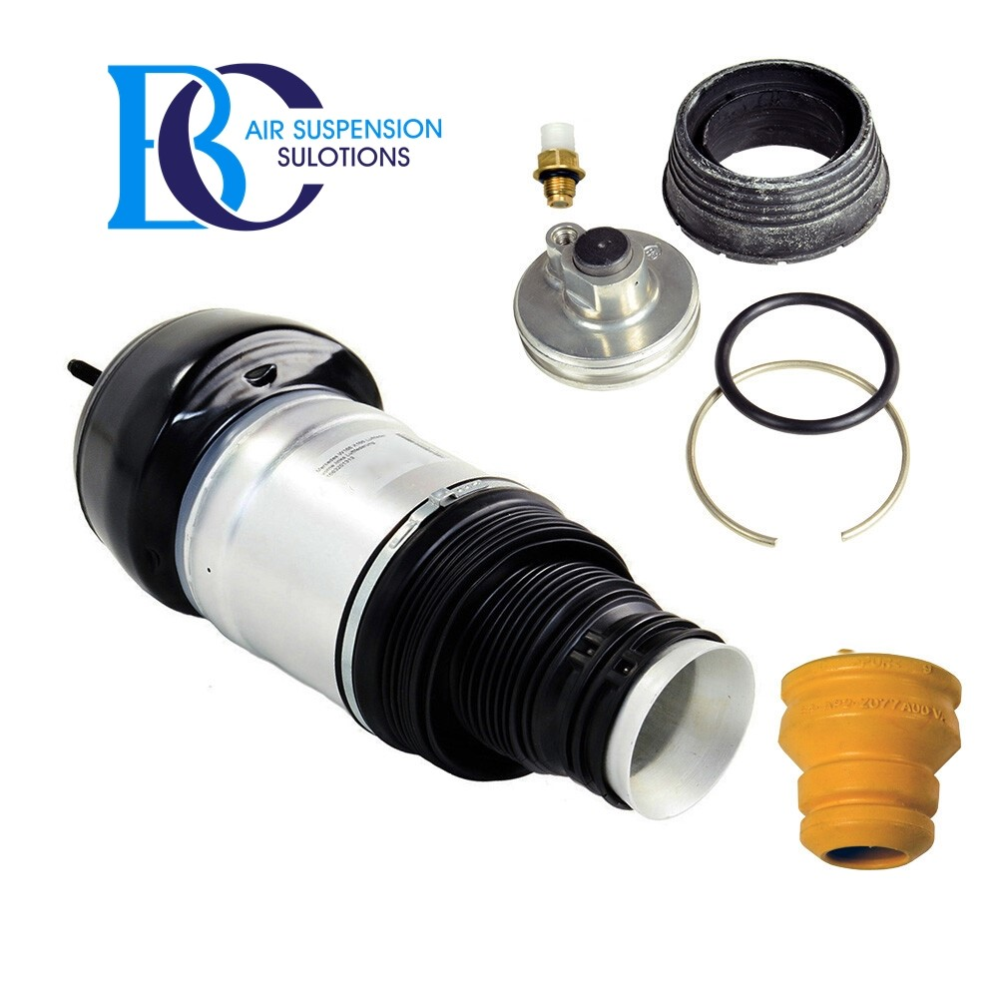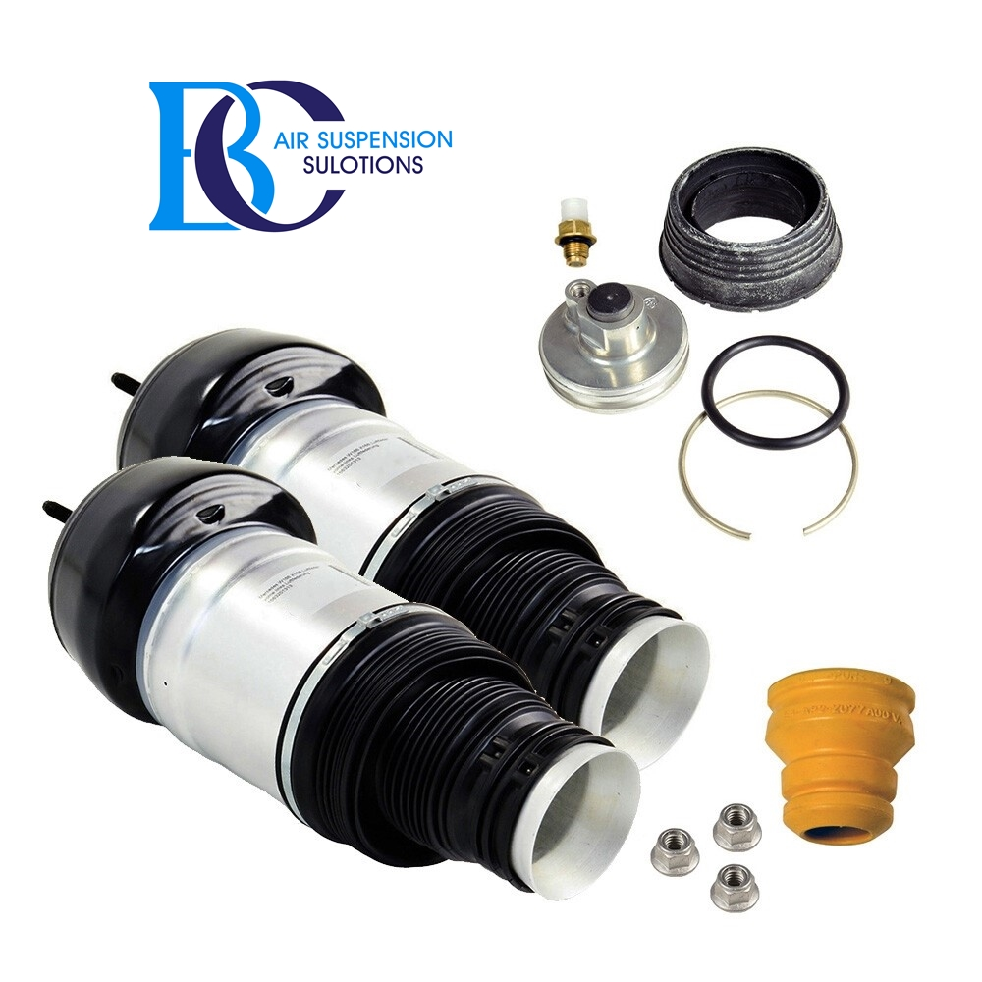

Description

If the air strut (A1663205166, A1663205366) is defective but the shock absorber still has the best properties, you can use this set to restore the function of the complete shock absorber of the Mercedes GLE (W166).

This is a air spring kit for the complete suspension strut.

This means that you would have to buy a complete strut. Repairing the strut makes sense only if the shock absorber still has a sufficient efficiency.

This kit should not be used for oil leaking shock absorbers.

If the air strut is broken, but the shock absorber still has the best properties, you can use this set to restore the function of the complete shock absorber.

**Can be installed in the following vehicles:**

Mercedes-Benz GLE W166 (2015-2018)

ML/GLE 250 BlueTEC/d 4MATIC (166004) 04.2015 - 10.2018

ML/GLE 250 BlueTEC/d (166006) 04.2015 - 10.2018

ML/GLE 350 BlueTEC/d 4MATIC (166024) 04.2015 - 10.2018

ML/GLE 350 4MATIC (166057) 11.2015 - 10.2018

ML/GLE 350 (166058) 11.2015 - 10.2018

ML/GLE 400 (166059) 01.2015 - 07.2015

ML/GLE 300 4MATIC (166062) 11.2015 - 10.2018

ML/GLE 500 4MATIC HYBRID/E (166063) 04.2015 - 10.2018

ML/GLE 450 SPORT AMG 4MATIC (166064) 10.2015 - 04.2016

**OEM part numbers (shock absorbing strut):**

A1663205166, A1663206913, A1663201313, A166320516680

A1663205366, A1663207113, A1663206713, A166320536680

# **Mercedes GLE W166 AIRMATIC Air Spring Suspension Kit (Front Right)**





Description

If the air strut (A1663205266, A1663205466) is defective but the shock absorber still has the best properties, you can use this set to restore the function of the complete shock absorber of the Mercedes GLE (W166).

This is a air spring kit for the complete suspension strut.

This means that you would have to buy a complete strut. Repairing the strut makes sense only if the shock absorber still has a sufficient efficiency.

This kit should not be used for oil leaking shock absorbers.

If the air strut is broken, but the shock absorber still has the best properties, you can use this set to restore the function of the complete shock absorber.

**Can be installed in the following vehicles:**

Mercedes-Benz GLE W166 (2015-2018)

ML/GLE 250 BlueTEC/d 4MATIC (166004) 04.2015 - 10.2018

ML/GLE 250 BlueTEC/d (166006) 04.2015 - 10.2018

ML/GLE 350 BlueTEC/d 4MATIC (166024) 04.2015 - 10.2018

ML/GLE 350 4MATIC (166057) 11.2015 - 10.2018

ML/GLE 350 (166058) 11.2015 - 10.2018

ML/GLE 400 (166059) 01.2015 - 07.2015

ML/GLE 300 4MATIC (166062) 11.2015 - 10.2018

ML/GLE 500 4MATIC HYBRID/E (166063) 04.2015 - 10.2018

ML/GLE 450 SPORT AMG 4MATIC (166064) 10.2015 - 04.2016

**OEM part numbers (shock absorbing strut):**

A1663205266, A1663207013, A1663201413, A166320526680

A1663205466, A1663207213, A1663206813, A166320546680

# **Mercedes GLE 450,Air suspension strut AIRMATIC (Front Left)**

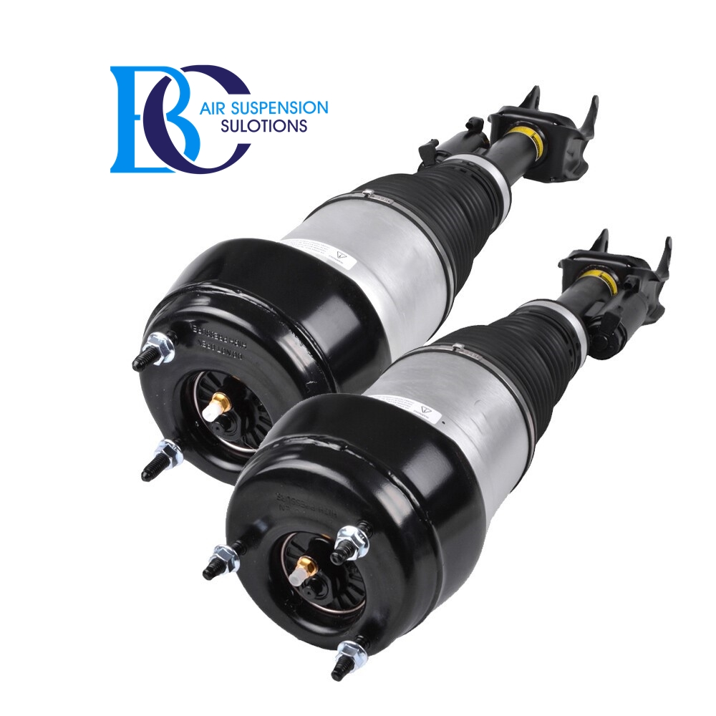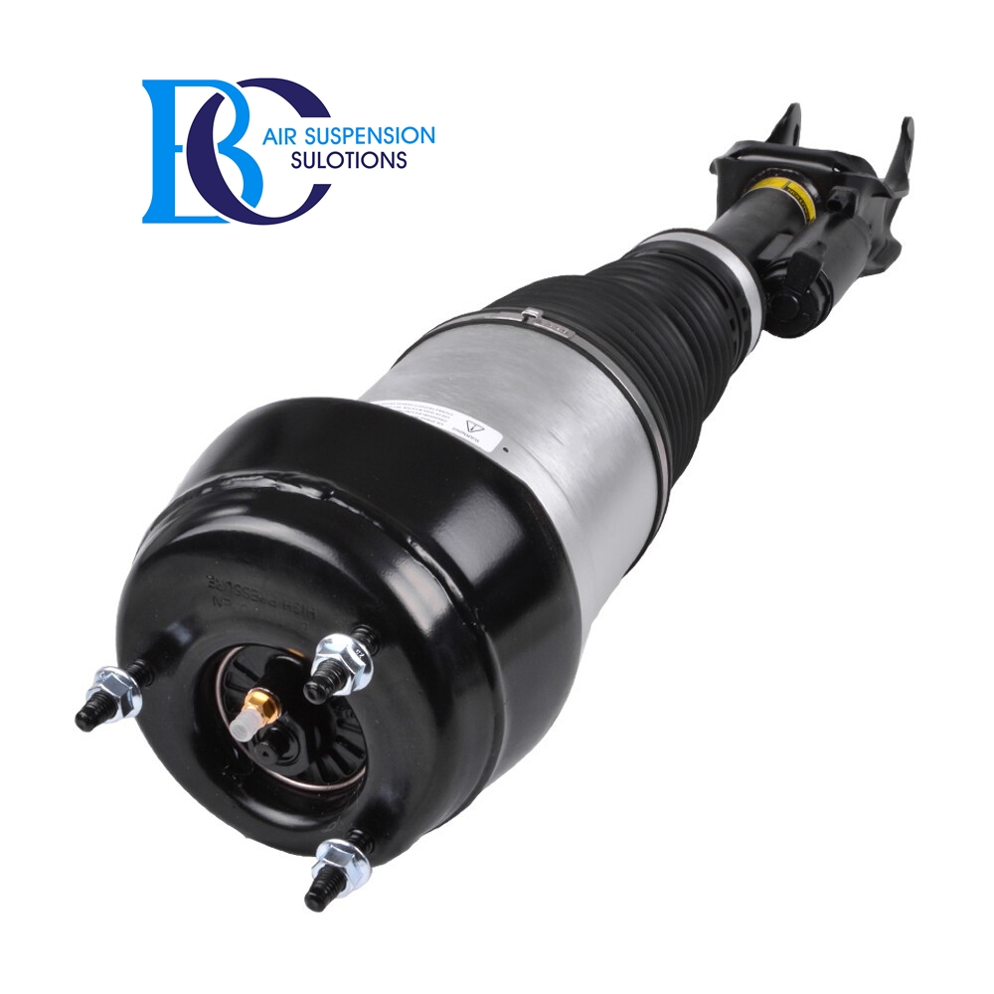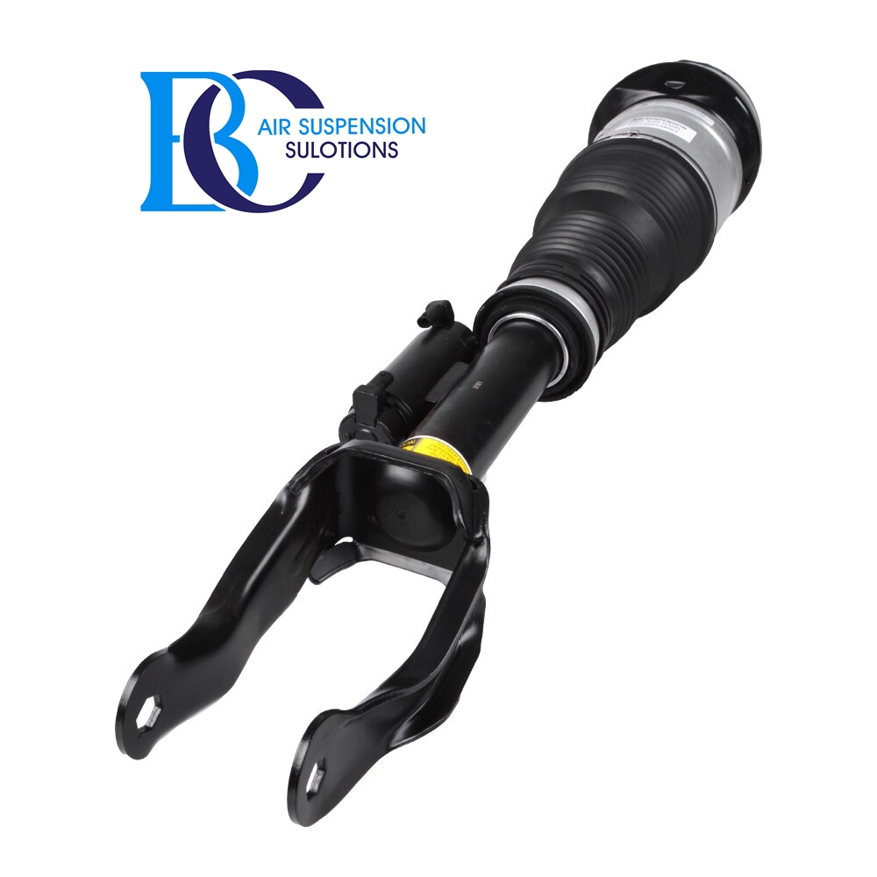

Description

This front left ADS+ shock absorber A2923202500 for the air suspension is suitable for the Mercedes ML / GLE 450 SPORT AMG 4MATIC.

**Can be installed in the following vehicles:**

Mercedes ML/GLE 450 SPORT AMG 4MATIC GLE-SPORT 10.2015 - 04.2016

ADS+ (Adaptive Damping System Plus)

**OEM part number:**

A2923202500, A292320250080, A292320250038, A2923203913, A292320391380

2923202500, 292320250080, 292320250038, 2923203913, 292320391380

# **Mercedes GLE 450,Air suspension strut AIRMATIC (Front Right)**

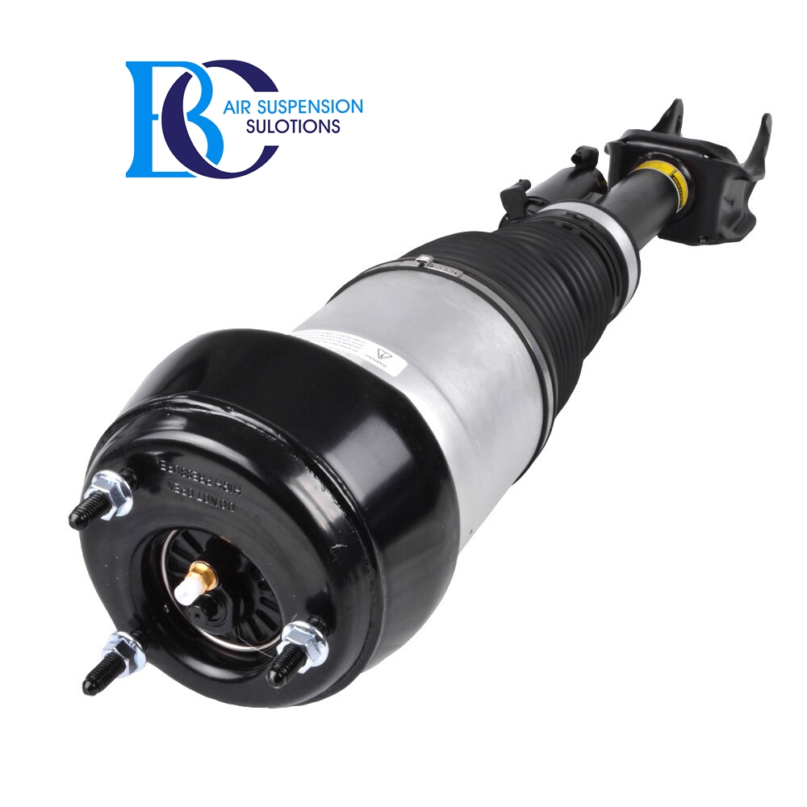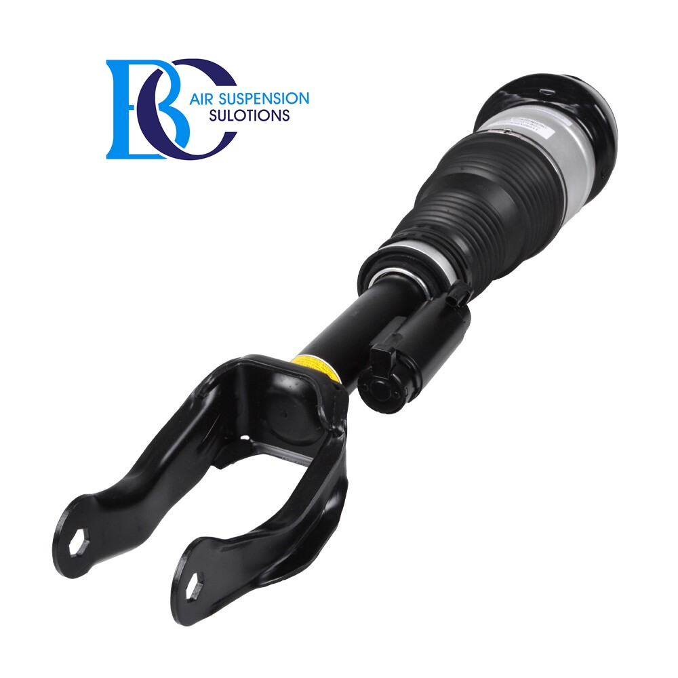

Description

This front right ADS+ shock absorber A2923202600 for the air suspension is suitable for the Mercedes ML / GLE 450 SPORT AMG 4MATIC.

**Can be installed in the following vehicles:**

Mercedes ML/GLE 450 SPORT AMG 4MATIC GLE-SPORT 10.2015 - 04.2016

ADS+(Adaptive Damping System Plus)

**OEM part number:**

A2923202600, A292320260080, A292320260038, A2923204013, A292320401380

2923202600, 292320260080, 292320260038, 2923204013, 292320401380

# **Mercedes GLE (W166) AMG 63 Air spring air suspension rear side**

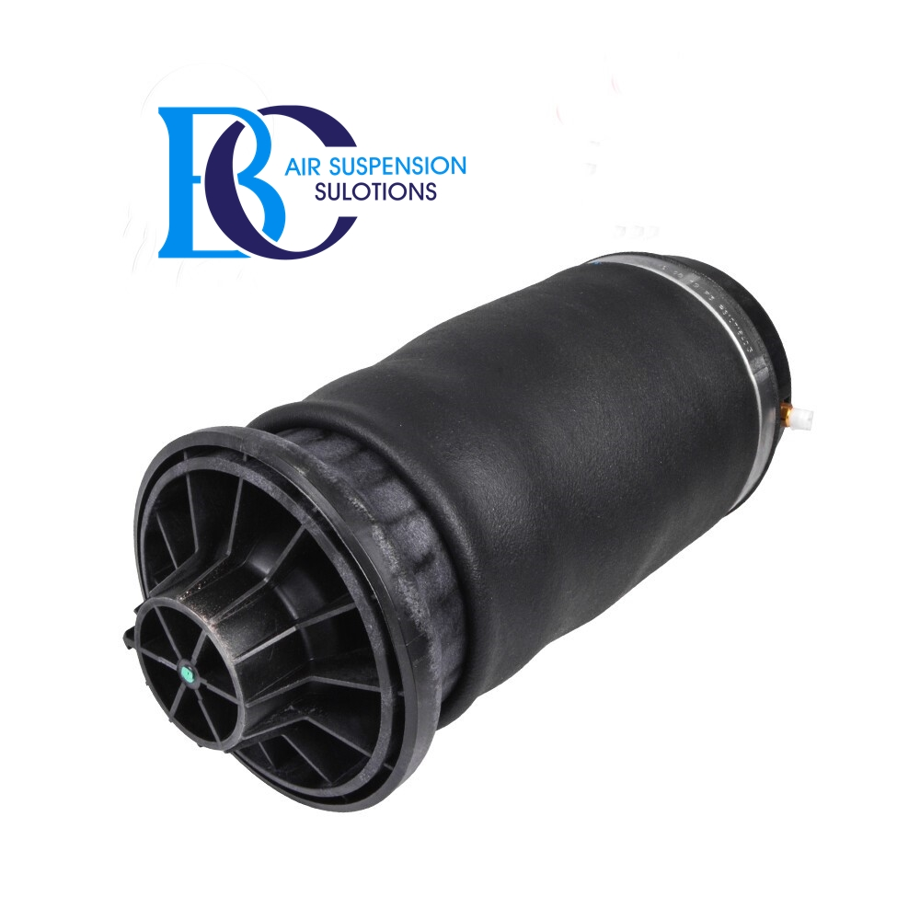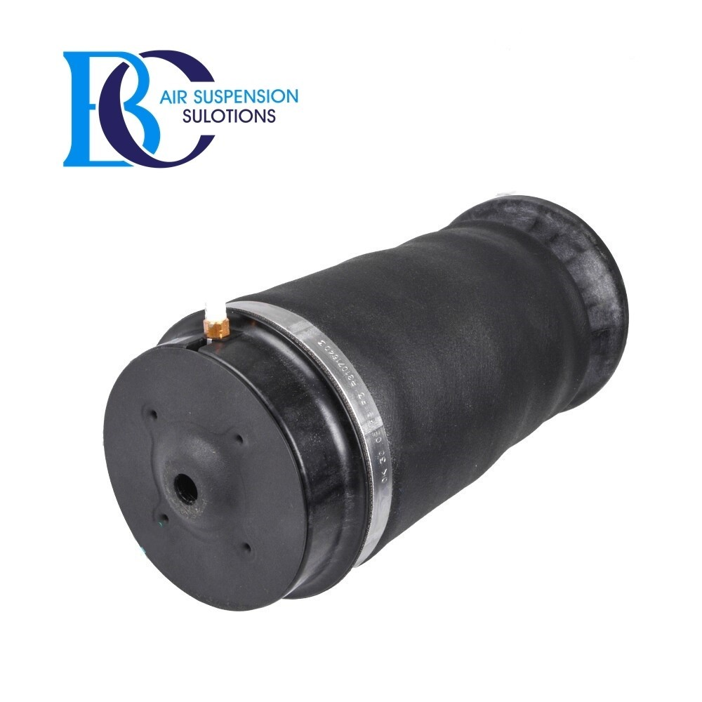

Description

This rear air spring A1663200625 for the Mercedes GLE (W166) AMG 63.  
   
**Can be installed in the following vehicles:** Mercedes GLE (W166) AMG 63 4-matic (166.074) 04.2015-10.2018  
 Mercedes GLE (W166) AMG 63 S 4-matic (166.075) 04.2015-10.2018

**OEM part number:**

A1663200625, 1663200625

# **Mercedes GLE 450, AIRMATIC Shock absorber ADS+ (REAR)**

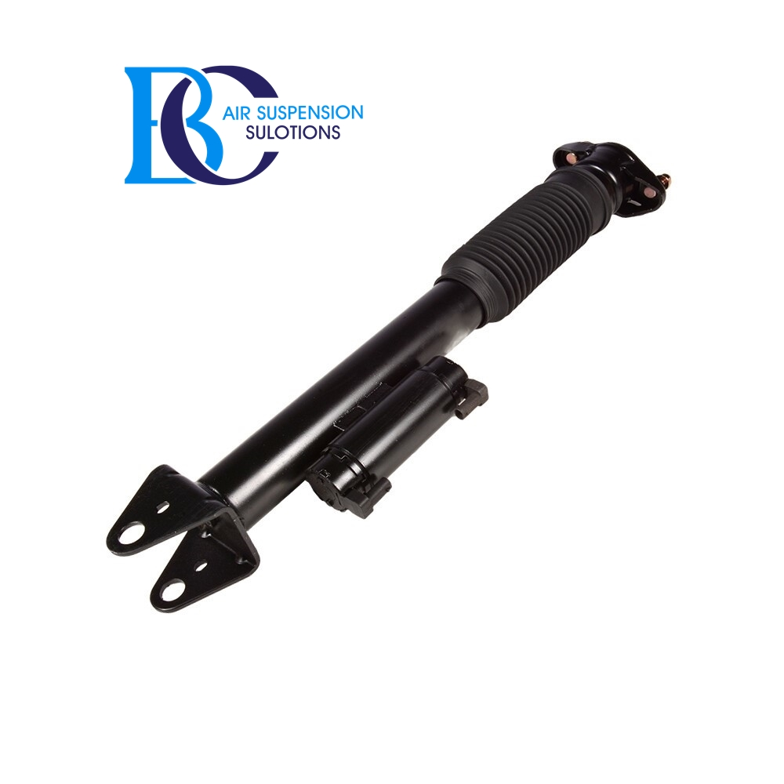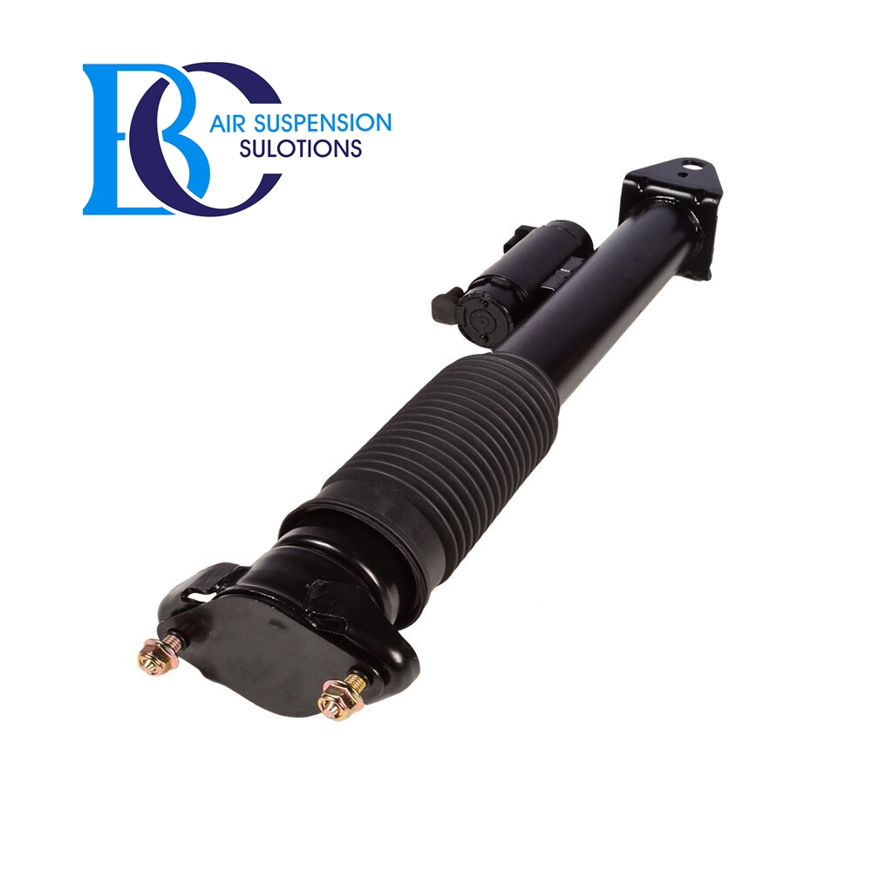

Description

This rear shock absorber (A2923201600, A2923200600) for the Adaptive Damping System PLUS (ADS +) of the Mercedes ML / GLE 450 Sport AMG.  
   
 **Can be installed in the following vehicles:** Mercedes ML/GLE 450 Sport AMG 4MATIC 10.2015-10.2018

**OEM part number:**

A2923201600, A2923200600, 2923201600, 2923200600

# **Mercedes GLE W166 Compressor air suspension AIRMATIC**

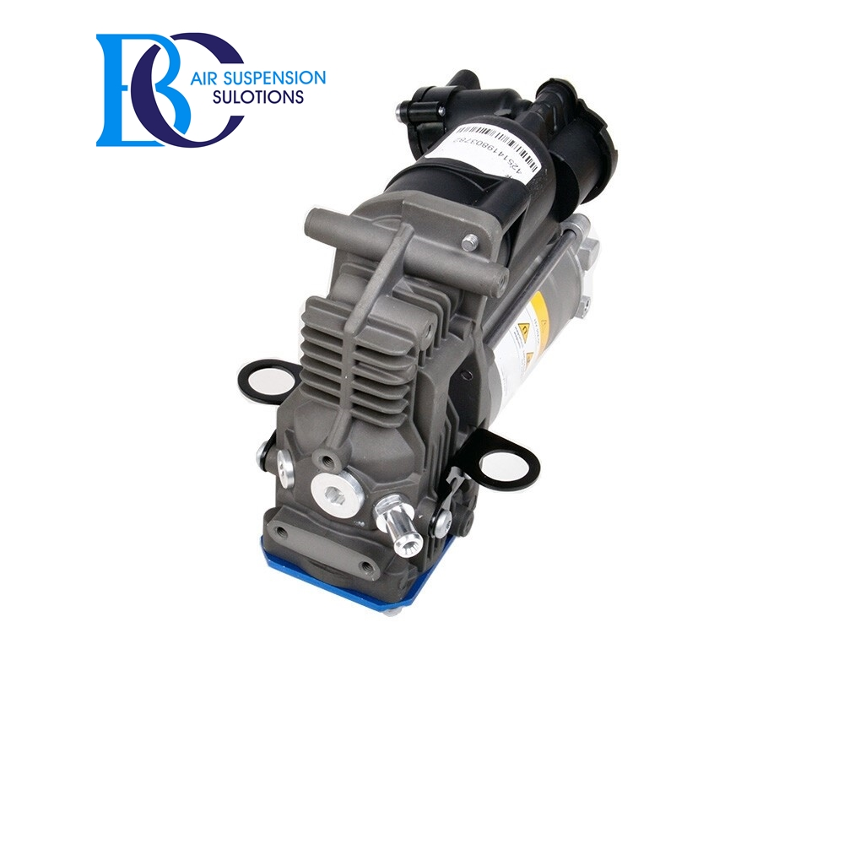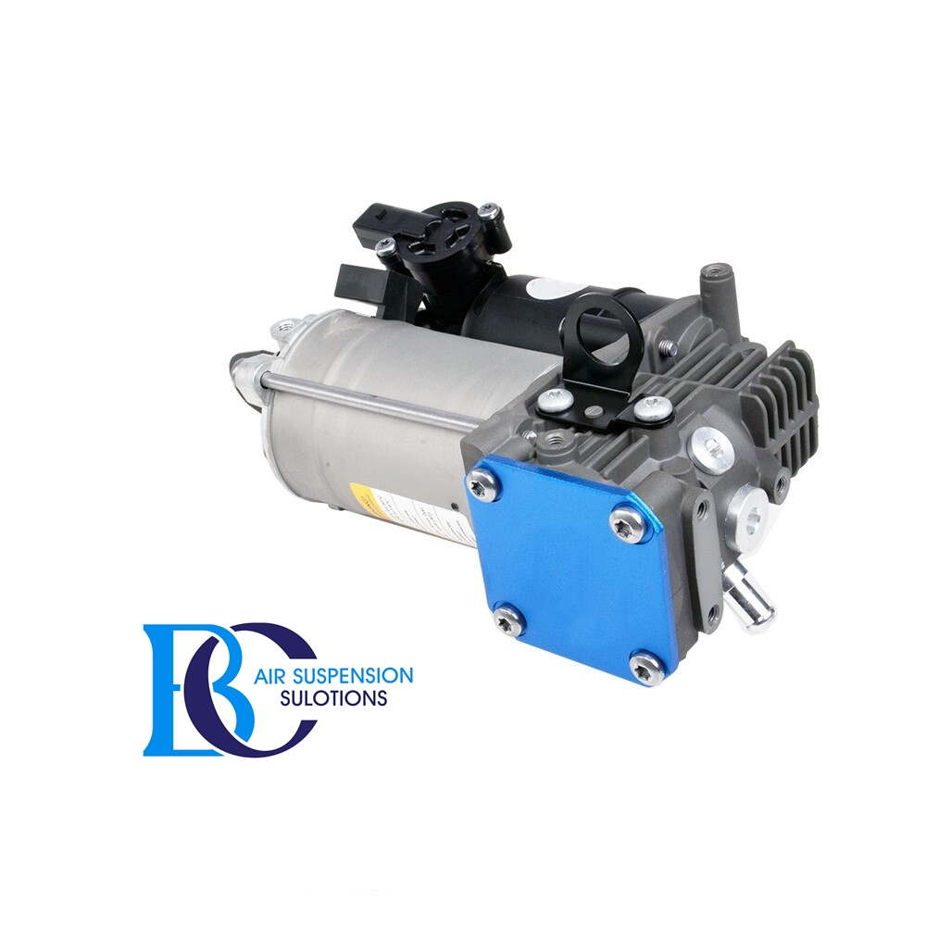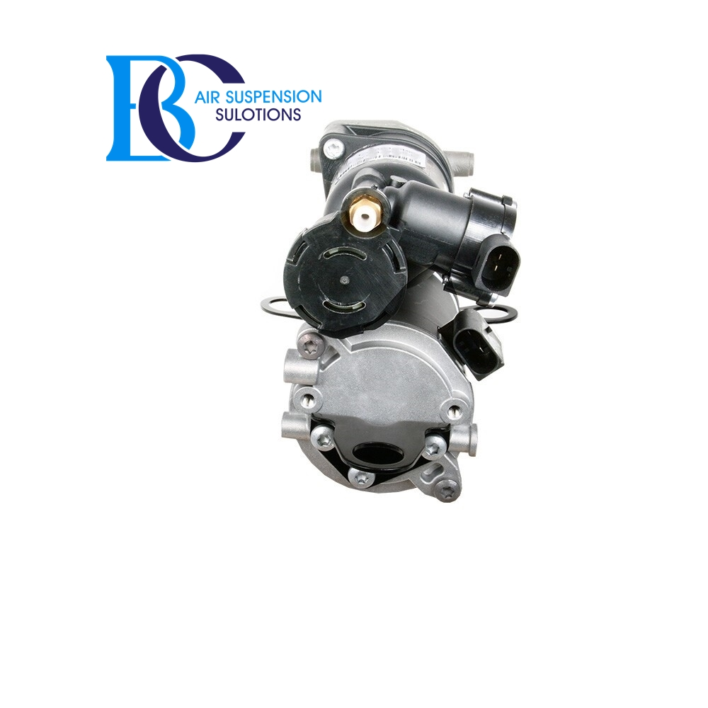

Description

This is air compressor A1663200104 for the Mercedes ML/GLE-Class W166.

**Can be installed in the following vehicles:**

Mercedes-Benz GLE, W166 (2015-2018)

**OEM part number of the air supply system:**

A1663200104, 1663200104

A166320010480, 166320010480

A1663200204, 1663200204

# **Mercedes GLE W166 Valve block air suspension A2123200358 Airmatic**

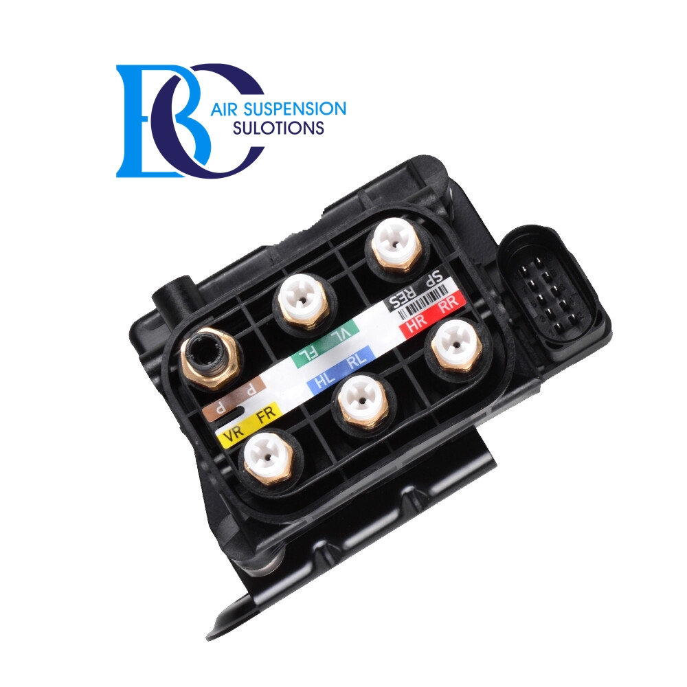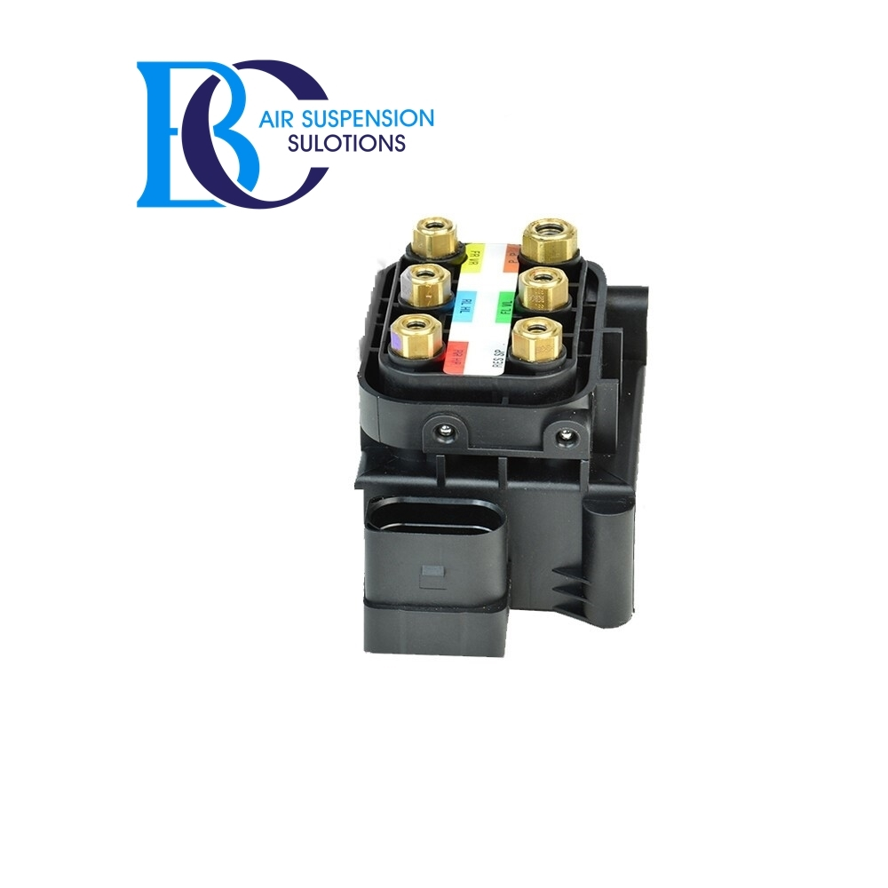

Description

This control valve block A2123200358 for the air suspension of the Mercedes GLE-Class W166.

**Can be installed in the following vehicles:**

Mercedes-Benz W 166 GLE-Class (2015-2018)

GLE 250 d (166.006)

GLE 250 d 4-matic (166.004)

GLE 320 4-matic (166.062)

GLE 350 d 4-matic (166.024)

GLE 400 4-matic (166.056)

GLE 500 4-matic (166.073)

GLE 500 e 4-matic (166.063)

GLE AMG 43 4-matic (166.064)

GLE 450 AMG 4-matic (166.064)

GLE AMG 63 4-matic (166.074)

GLE AMG 63 S 4-matic (166.075)

**OEM part numbers:**

A2123200358, 2123200358

# **B.- AIRMATIC WITHOUT ADS**

# **Mercedes GLE W166 Air suspension strut AIRMATIC (Front Left)**

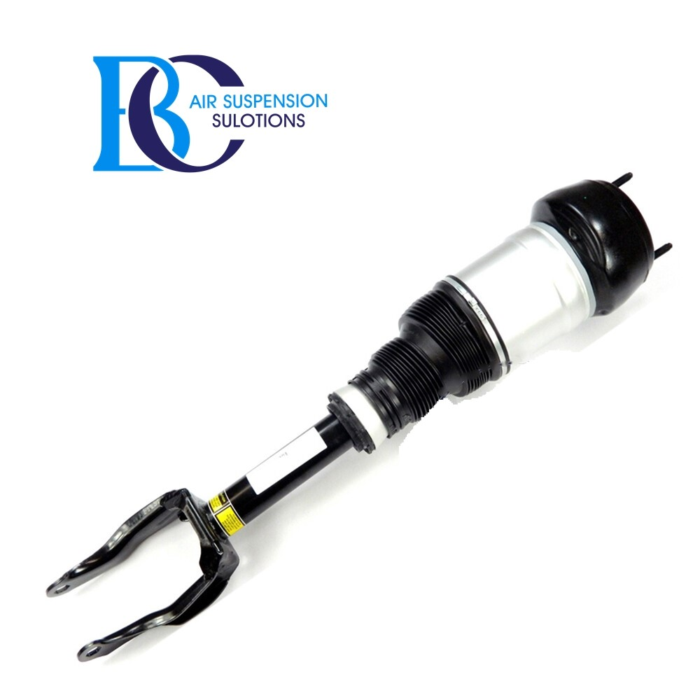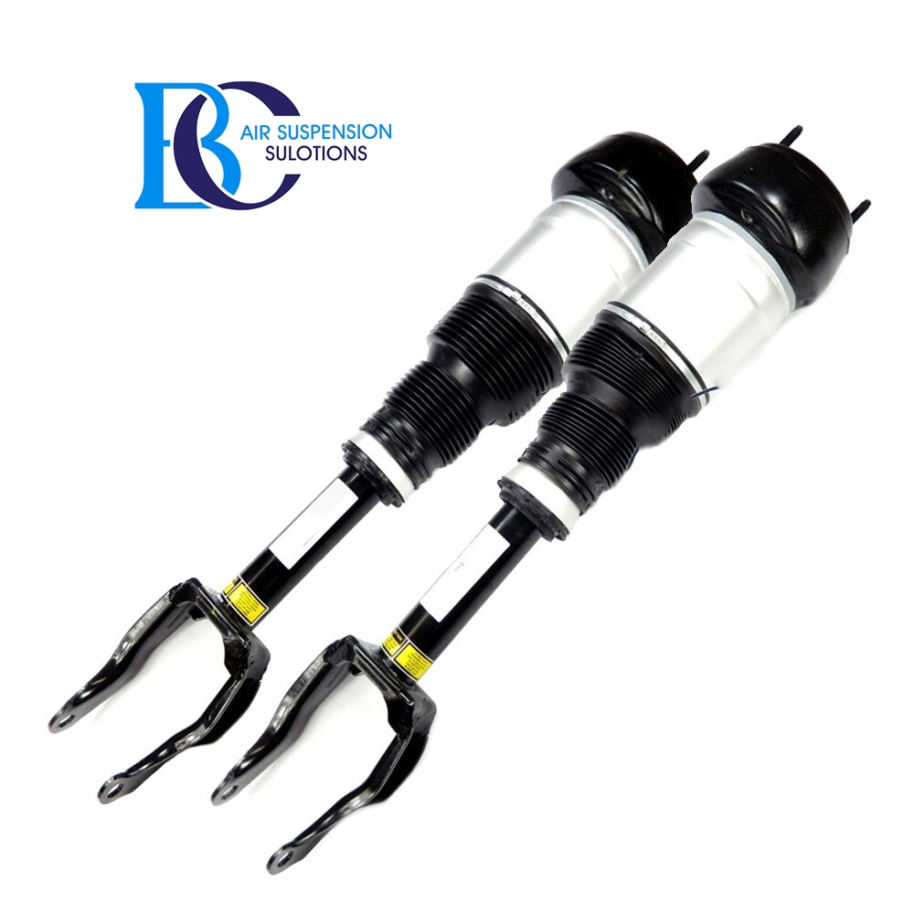

Description

This Airmatic DC / air suspension semi-active air suspension strut A1663204966 fits the Mercedes-Benz GLE W166 front left side without adaptive damping control (ADS).

**Can be installed in the following vehicles:**

Mercedes-Benz GLE, W166 2015/04-2018/10

500 4-matic (166.073) 2015/10-2018/10

320 4-matic (166.062) 2015/10-2018/10

350 d 4-matic (166.024) 2015/04-2018/10

350 d 4-matic (166.024) 2015/04-2018/10

400 4-matic (166.056) 2015/04-2018/10

450 AMG 4-matic (166.064) 2015/10-2018/10

AMG 43 4-matic (166.064) 2016/05-2018/10

**OEM part number:**

A1663204966, 1663204966, A1663202513, 1663202513, A166320496680, 166320496680, A1663207313, 1663207313

# **Mercedes GLE W166 Air suspension strut AIRMATIC (Front Right)**

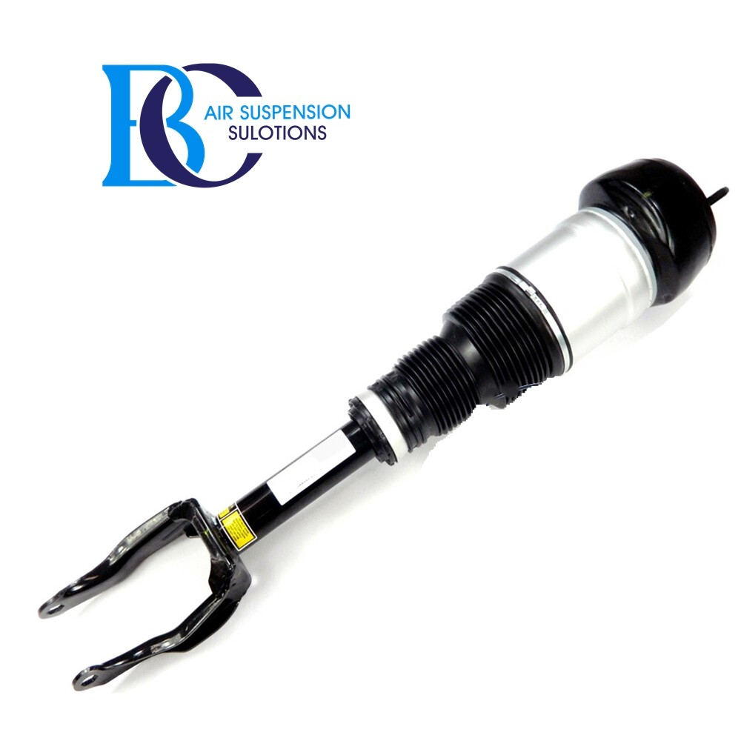

Description

This Airmatic DC / air suspension semi-active air suspension strut A1663205066 fits the Mercedes-Benz GLE W166 front right side without adaptive damping control (ADS).

**Can be installed in the following vehicles:**

Mercedes-Benz GLE, W166 2015/04-2018/10

500 4-matic (166.073) 2015/10-2018/10

320 4-matic (166.062) 2015/10-2018/10

350 d 4-matic (166.024) 2015/04-2018/10

350 d 4-matic (166.024) 2015/04-2018/10

400 4-matic (166.056) 2015/04-2018/10

450 AMG 4-matic (166.064) 2015/10-2018/10

AMG 43 4-matic (166.064) 2016/05-2018/10

**OEM part number:**

A1663205066, 1663205066, A166320506680, A166320506638

A1663202613, 1663202613, A1663207413, 1663207413

# **Mercedes GLE W166 AIRMATIC Shock absorber without ADS (REAR)**

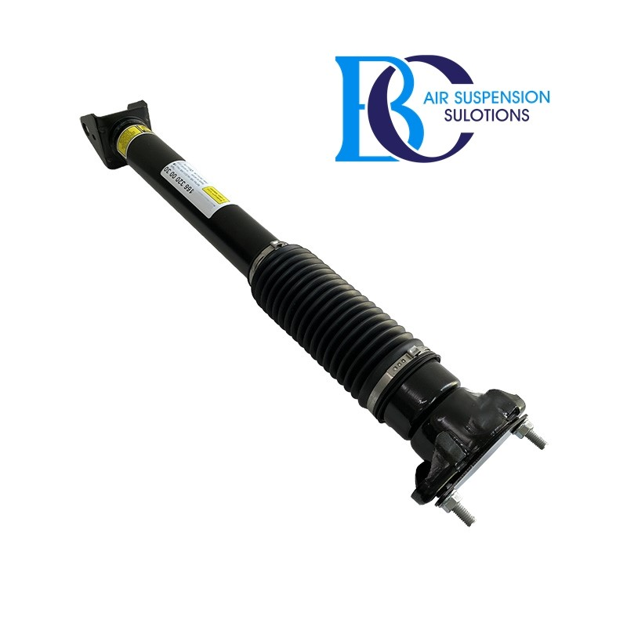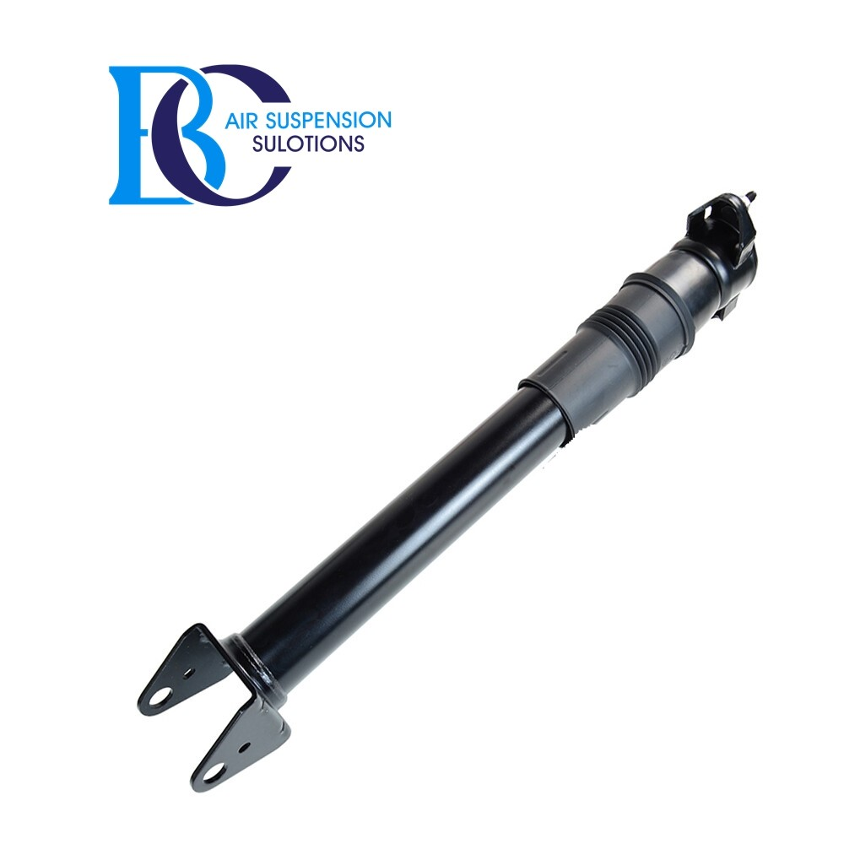

Description

This is a new shock absorber for rear side.

**Can be installed in the following vehicles:**

Mercedes-Benz GLE, W166 2015/04-2018/10

250 d (166.006) 2015/04-2018/10

250 d 4-matic (166.004) 2015/04-2018/10

320 4-matic (166.062) 2015/10-2018/10

350 d 4-matic (166.024) 2015/04-2018/10

350 d 4-matic (166.024) 2015/04-2018/10

400 4-matic (166.056) 2015/04-2018/10

450 AMG 4-matic (166.064) 2015/10-2018/10

AMG 43 4-matic (166.064) 2016/05-2018/10

**OEM part number:**

A1663201130, 1663201130, A1663201730, 1663201730, A1663201830, 1663201830, A1663261500, 1663201530, A1663200030, 1663200030, A1663200530, 1663200530